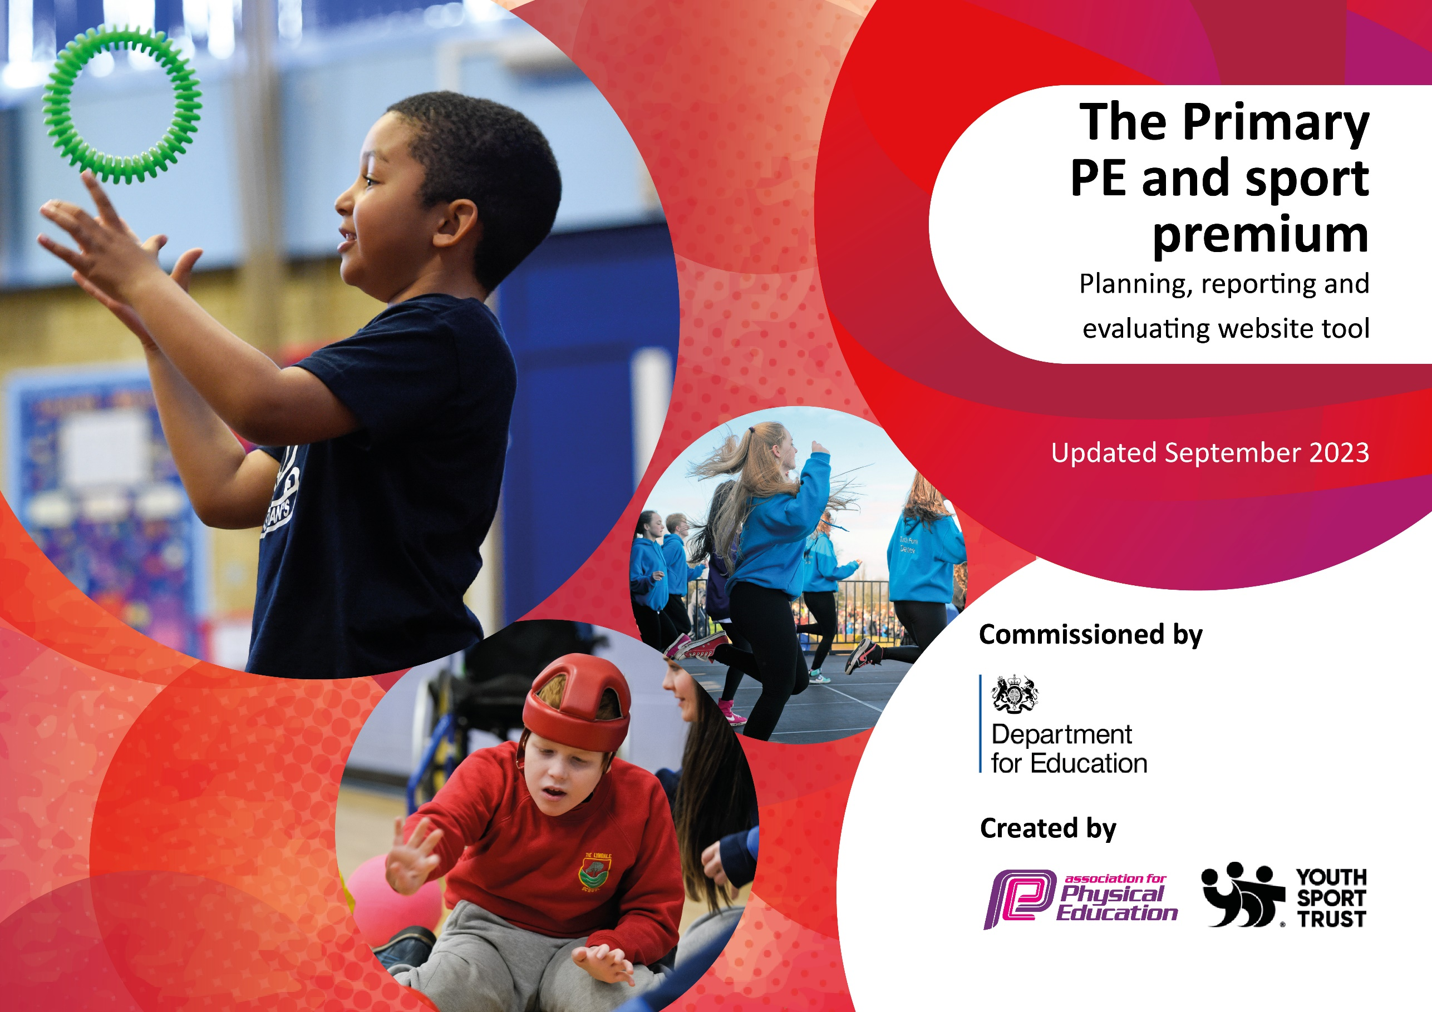

Windmill L.E.A.D. Academy effective use of the Primary PE and Sport Premium Action Plan 2024/2025
School Physical Education Objective:
To develop a physical education and school sport programme that offers opportunities for children to participate in range of activities and competitions, thus increasing participation and promoting healthy and active lifestyles.
The allocation of sports premium funding this year is £19,390
From sports premium funding it’s expected that schools will see an improvement against the following 5 key indicators:
- The engagement of all pupils in regular physical activity – kick-starting healthy active lifestyle
- The profile of PE and sport being raised across the school as a tool for whole school improvement
- Increased confidence, knowledge and skills of all staff in teaching PE and sport
- Broader experience of a range of sports and activities offered to all pupils
- Increased participation in competitive sport
The strategies have been highlighted to reflect upon previous years actions.
Sustainability:
Please note: In addition to the above we ensure that our Sports Premium spending leads towards sustainable outcomes and provision, e.g. that our pupils will have quality provision across their time with us from when they join to when they leave.

- The engagement of all pupils in regular physical activity – kick-starting healthy active lifestyle

Key Action | Strategies/ Time scale | Impact/ Success Criteria | Evidence
To offer over two hours a week of high quality Physical Education/School Sport for every child in Key Stage 1 & 2 | All children to have 2 hours (including changing time) of timetabled PE with Mr Rose or class teacher (Autumn 1).  Include (including swimming at key times of the year) of PE on school timetable for classes (Autumn 1).  Continue to develop a broad and balanced PE curriculum with many different activities that are appropriate for the school and our children (Autumn 1).  Have many opportunities for extra-curricular opportunities. Minimum 9 clubs a week.  Continue with morning clubs and variety of clubs. (3 clubs a week in mornings)  Offer lunchtime sports activities for the children to enjoy (On going).  Continue with the involvement of sports leaders at lunch times and for inter class competitions.  Increase the interclass competition calendar with more lunch competitions throughout the year. | Children have many opportunities to be active  Children are enthusiastic to take part in sport and physical activity  Children increase their physical literacy and life skills  100% of children feel confident to participate in PE and sport  100% of children report that they enjoy sport  Sports leaders to support at lunch times.  Sustainability:  This provision is embedded within our practice and given priority within the school timetable. Across Key Stage One and Key Stage Two there is access to a minimum of two hours of PE in every year group. | 90%+ Children on or above age related attainment  Lesson observations by SLT  PE Long term Plan  Timetable  Extra-curricular timetable  And registers  Pupil voice, end of year questionnaire  Teacher feedback regarding active play ideas
To evidence pupil learning, progress and attainment in PE. | Assessment for learning to be carried out during PE lessons.  To use assessment protocol/ policy to track and monitor progress (On going).  Termly assessment to be carried out.  Mr Rose to communicate with keys stage 1 staff of the assessment protocol that will be carried out (autumn 1). | Children have a knowledge of what they are learning and how to improve  Children are confident in self and peer assessment  100% of children are making good progress in physical Education  Minimum 90% of children on or above age related attainment by the end of the year  Sustainability:  This provision is embedded within our practice. We check progress each term and undertake a full annual review to ensure we sustain quality progress and attainment for every cohort every school year. | Termly assessment data, culminating in an end of year level  Lesson observations
To further develop techniques to support all learners during Physical Education | Mr Rose to plan and deliver lessons (On going).  Have differentiated lesson objectives (on going).  Differentiation during PE lessons (on going).  Broad and varied curriculum (Autumn 1).  Continue to improve dance provision in school, continue with successful dance extra-curricular program. Training from dance specialist.  Use different teaching and learning techniques to drive learning (on going). | All children to make good progress in Physical Education  Children enjoy Physical Education and are confident to participate  100% of children making good progress  Sustainability:  This provision is embedded within our practice. We review the provision of techniques and support via professional dialogue, learning walks and observations. | Lesson observations  SMT learning walks  Pupil voice, end of year questionnaire/ pupil interviews  Assessment data  Extra-curricular register
To increase the sporting opportunities of pupil premium children and children who have social and emotional barriers. | Encourage pupil premium/key children to take part in extra- curricular programme (On going).  Ensure when choosing children for sports clubs. Try to vary this to get maximum number of children at a sports club. | Improve confidence in key children  Improve life/social skills in key children  Improve children’s self esteem  Assessments show improved attitudes and behaviours  Sustainability:  This provision is embedded within our practice. We review the provision of techniques and support via professional dialogue, learning walks and observations. | Club registers with pupil premium related  Timetable  Pupil voice
To ensure PE resources are available, appropriate and fit for purpose | Provide a range of PE equipment that is safe and appropriate for all children throughout school (Autumn 1).  To clarify the distinction between break/lunchtime equipment, curriculum sessions and active break (Autumn 1).  Ensure there is spare kits, footwear and swim kit available for children (Autumn 1).  Replenish equipment that is needed.  Replace damaged football goals.  Replace damaged sports equipment.  Repair equipment through sports safe. | Resources are organised and correct  Extra-curricular clubs have the correct equipment to run effectively  Sustainability:  Each year we review and renew this provision – a full stock take and review against the teaching and learning plan to ensure pupils access the appropriate resources required for high calibre sports provision. | Order forms  Equipment  School PE Kit  Swim kits
Healthy and active lifestyles club | Continue with a morning healthy active lifestyles club (Spring 1)  Teach children about the importance of physical activity through PE curriculum (ongoing).  Teach children about the importance of healthy eating  (Autumn 1/ ongoing).  Complete the Windmill schools mile challenge competition – linking this to healthy lifestyle scheme of work. | All children are able to make healthy food choices.  Targeted children make informed choices about a healthy and active lifestyle.  The children identified will take part in more sports clubs throughout the year.  Sustainability:  This provision is embedded within our practice. Pupils across Key Stage One and Key Stage Two access high quality sport provision both before and after the school day. | Club registers  Pupil feedback  Test children’s knowledge
Develop up to date schemes of work in line with Ofsted subject specialism documents | CPD for teachers on half termly schemes of work | Improved teaching and learning in physical education across the school when lessons are taught by class teachers – 100% of lesson graded as ‘good’.  Improve teachers knowledge and confidence in teaching physical education  Sustainability:  This provision is embedded within our practice. We review the provision of techniques and support via professional dialogue, learning walks and observations. | Teacher feedback  SLT learning walks  Mr Rose feedback
To continue our improvements in school swimming by offering year 6 swim/catch up sessions after the year 4 curriculum. | Year 6 school swimming – Extra to improve results | Improved swimming results  Improved confidence in water  When leave Windmill L.E.A.D. Academy children more likely to swim – lead a healthy and active lifestyle.  Sustainability:  This provision is embedded within our practice. We review the provision of techniques and support via professional dialogue, learning walks and observations | results

Costs:
General PE equipment/play time equipment. Including goals and play time equipment etc: £1800
Sports safe repairs £632
PE shoes, spare PE kits, swimming wear (trunks and costumes): £500
Year 6 catch up swimming: £2,868.00

2: The profile of PE and sport being raised across the school as a tool for whole school improvement
Key Action | Strategies | Impact/ Success Criteria | Evidence
To continue to raise the profile of sport throughout the school and with parents | Actively encourage children’s participation in school sport (On going)  Make parents and children aware of how sport is encouraged and taught in school  Trophies awarded to the sports teams at the end of the year  Results and achievements celebrated in assembly  Add new pictures to the Windmill L.E.A.D. Academy school sports board.  Use Twitter on a regular basis to recount sporting success and competitions. | Parents and children celebrate school success  Children are motivated to take up extra-curricular clubs and play for the school teams  Children have sporting role models in school  Children are more active  Children take part in extra-curricular clubs  Sustainability:  Our Sport Provision is an embedded aspect of our school life, with a consistent high profile. For example Y3 and Y4 pupils know they can work towards joining our Basketball or Football teams in Y5 and Y6. | Twitter  School newsletters  Up to date sports board  Photos of children participating in sport and activities
Sports leadership | Create a group of Year 6 and 5 sports leaders. (Autumn 1)  These children will attend a weekly sports leadership club which they will develop their sports leadership skills.  Children will help during break and lunchtimes:  Being in charge of equipment and leading activities for the other children to do.  Helping during school sporting events e.g. sports day, sports relief, healthy-lifestyles day.  Support during extra-curricular clubs when available.  Support during their lessons | Give children ownership of sport  Increase awareness of sport and physical activity  Give children pride in their learning  Increase self-esteem and cooperation  Give children something to aim for  Teach children communication and leadership skills.  Sustainability:  Each year we have Sports Ambassadors. This ensures that pupils have a key role in the promotion of and sustainability of sport as a key aspect of our school provision each year. | Club register  Observations
Healthy and active lifestyles | Continue to teach healthy and active lifestyles in the curriculum.  Year 5 and 6: Have termly class fitness sessions where the children do an activity and their totals are added up, and a school leader board that will be shared with the school.  Sports relief mile challenge and sporting activities throughout the year.  Sports day will be a big event again emphasising the importance of sport.  Healthy and active lifestyles club which will be delivered once a week in the morning with an emphasis on fitness and running.  This will be beginning in Spring 1  Boxercise club for key stage 2 in the summer term | Improve knowledge on health and wellbeing.  Raise awareness of school sport and exercise  Create licks between social, physical and mental health.  Sustainability:  This provision is embedded within our practice. A wide range of elements contribute to the sustainability of this. Clubs, teams, sports ambassadors, a minimum of two hours for pupils in KS1 and KS2. | Planning  Observations  Feedback from the large events  Communication with staff
Costs:
Trophies & medals : £500
Team bus travel: £3000
Events cost: £200
3. Increased confidence, knowledge and skills of all staff in teaching PE and sport
Key Action | Strategies | Impact/ Success Criteria | Evidence
To promote Derby SSP resources as easy to follow resources for teachers to use. | Give high quality CPD on teaching resources.  Teaching resources available  Regular communication with year 1 teaching staff and foundation about physical education.  Lesson plans given to staff who are teaching physical education. | Improve teaching and learning in physical education across the school  Improve teachers knowledge and confidence in teaching physical education  Sustainability:  This provision is embedded within our practice. Appropriate CPD time is provided every year within the annual planner. | Teacher feedback  SLT learning walks  Lesson observation feedback
To give staff the skills and confidence to deliver Physical Education lessons | PE specialist (Mr Rose) is a full time member of staff and part of the schools long term plan  Teachers and Teaching Assistants regularly observe and team teach in PE lessons taught PE specialist  Regular communication with year 1 teaching staff and foundation about physical education.  PE lessons planned for staff when Mr Rose isn’t delivering them.  An open door policy where staff can observe Mr Rose in their PPA time as part of their professional development. | Teachers feel confident in the teaching of PE and deliver good PE lessons.  Staff regularly offer extra-curricular sports clubs  If Mr Rose is off site staff are confident enough to teach a PE lesson  Sustainability:  This provision is embedded within our practice. Appropriate CPD time is provided every year within the annual planner. In addition to this observations of expert practice are provided to ensure sustained skills for all staff. | Communication with staff
Schemes of work that can be delivered by all staff | Teachers will use Derby City SSP schemes of work when Mr Rose isn’t teaching.  Mr Rose will provide teaching materials for year 1 and 2. Easy to follow lesson plans. With regular communication.  Lesson plans will be given to staff at the start of each half term. | Teachers are confident in delivery of PE lessons if Mr Rose is absent.  Children continue their high quality PE if Mr Rose is absent.  Enjoyable and engaging PE lessons in all circumstances.  Sustainability:  This provision is embedded within our practice. Appropriate CPD time is provided every year within the annual planner. Professional leadership is provided by the Sport Leader to other practitioners. | Scheme of work reviewed.
No costs for sports premium.

4: Broader experience of a range of sports and activities offered to all pupils
Key Action | Strategies | Impact/ Success Criteria | Evidence
To further develop new in school techniques to improve children’s’ experiences of outdoor and adventurous activities. | To use Derby SSP scheme of work to support with this development.  For each class to access woodland learning for two lessons at Edale Rise. (On going)  To give year 6 children the opportunity to go on an outdoor and adventurous activities residential (Autumn 1 begin to find new places)  To include team building activities within the school PE curriculum. | To enhance teamwork and communication skills of our children  To give children more opportunity to learn about the wilderness and the environment  To improve confidence and self-esteem of our children.  Sustainability:  This provision is embedded within our practice. Each of these strategies are part of our annual offer every year. | Pupil voice  SLT learning walks
To provide a range of sporting, dance and outdoor activities to the PE curriculum | Mr Rose to develop a broad PE curriculum with additional different activities planned over the year  Have many opportunities for extra-curricular opportunities, especially for Year 5 & 6 and girls across school to increase their participation  Girls sports club in the mornings to increase participation. (Summer)  Have varied activities at lunchtimes for the children to enjoy.  Dance specialist to come in for 18 hours to teach across the school as part of our extra-curricular programme | Children have many opportunities to be active in a variety of ways, in PE lessons, extra-curricular clubs, playtimes, visits and through sporting events  Children increase their physical literacy and life skills  Children feel confident to participate in PE and sport  Children enjoy sport  Children progress through the ‘LEAD Award’  Sustainability:  This provision is embedded within our practice. Each of these strategies are part of our annual offer every year. | At least 80% of children are at or above age related attainment  Lesson observations  PE Long term Plan  Timetable of additional activities  Extra-curricular timetable and registers  Pupil voice, end of year questionnaire
To encourage Key Stage 1 and Foundation children to be physically active | Mr Rose to continue to offer a weekly Key Stage 1 Multi skills/PE club  Sports leaders to be given time during KS1 playtime to encourage sport through games and activities on the muga.  Dance club for key stage 1 for 6 weeks in the summer. | To get children in KS1 to be more physically active  Improving fitness/ motor skills/ physical literacy  Sustainability:  This provision is embedded within our practice. | Timetable  Action plan/ planning for afternoon fitness sessions
To continue links with outside agencies and sports clubs | To improve links with EPIC Partners, to encourage them to have more of an influence in our school.  Link with LEAD Academy Trust schools for competitions.  To encourage children to take part in the EPIC community games and SAS FC training  To use the School Newsletter to advertise the EPIC Events  To ask EPIC for any advertising material they use and distribute to children and parents  Epic to deliver golf sessions key stage 2 children as an extra-curricular opportunity. (summer)  Epic to deliver boxersize for key stage 2  Boxercise club – find a boxercise club through epic at key stage 2.  Epic sports to provide 3 different sports clubs.  To offer a dance extra-curricular club, link with ‘Unite the scene’. | Giving children more sporting opportunities outside of school  Giving children more opportunities for competition  To increase the school Extra-curricular programme  Sustainability:  This provision is embedded within our practice. As part of the Trust we have full access every year to the LEAD competitions and have a longstanding relationship with our local partners. | EPIC club registers  Pupils voice  LEAD competitions
To continue with high percentage of girls involvement in extra-curricular clubs | Girls only sports club to be held weekly in the mornings. (Spring 1)  Continue with fixtures for girls football team including a league.  Continue varied extra-curricular activities.  Year 5 and 6 begin to split the girls and boys up for competition to increase confidence.  Be conscious when choosing children for clubs that are over subscribed – make clubs have equal representation. | More involvement from girls – increase to at least 15 per year group.  Make healthy lifestyle choices  Become more active and engaged in PE  Sustainability:  This provision is embedded within our practice. We target key children or groups of children annually. | Club registers  Pupil voice  Mr Rose assessment during PE
To continue to improve dance provision and increase opportunities for dance at Windmill Academy | Give more time to dance in curriculum. Dance was not a thorough as wanted last year due to time constraints.  To offer a dance extra-curricular club at Windmill Academy.  Aim for 1 term for both key stage 1 and key stage 2 this year.  Use Derby SSP resources to improve dance lessons in the school.  Dance scheme of work to be followed by:  Year 2  Year 3  Year 5. | Give children confidence and self esteem  To improve schools dance provision  Sustainability:  This provision is embedded within our practice. Dance is a dedicated part of our curriculum offer ach year. | Pupil voice  Club register  SMT learning walks/observations
Aim for all children to do at least 30 minutes of activity a day, in line with the government recommendations. | All children have 2 hours of curriculum PE a week.  All children have the opportunity to take part in at least 1 extra-curricular sports club every week.  All children have the opportunity to participate in lunch sport on the MUGA  Sports leaders will lead activities at lunch time for other children, increasing activity levels.  Lunch time supervisors will lead activities on playground with correct/good equipment.  Have a minimum of 9 extra-curricular sports clubs running every week during the year.  Constantly have sports equipment available during play times for children to use together. | Increased physical activity  Sport and physical activity embedded in the school  Children enjoy and choose to do activity when possible  Children know the importance of physical activity and a healthy and active lifestyle.  Sustainability:  This provision is embedded within our practice. Dance is a dedicated part of our curriculum offer ach year. | Timetabling  ‘I can do this cards’  Photos of activity

Costs:
Extra-curricular specialists: £1800 (Dance Specialist)
Epic sports after school sports provision: £2000
Contribution to pre and after school club provision by PE Leader: £4090 (183.75 hours of provision at 5¼ hours per week for 35 weeks)

- Increase participation in competitive sport
Key Action | Strategies | Impact/ Success Criteria | Evidence
To continue to develop the already extensive school football and basketball programme and to participate in competitions within school and across schools. | When possible begin fixtures in line with government guidance.  Boys football league  Girls football league 8 games this year, the same as the boys.  Basketball league with Jimmy Jump shot mini basketball  Participate in fixtures with local L.E.A.D. Schools.  Girls football team y5-y6 once a week  Mr Rose to run the basketball training for years 5 and 6  Football training boys y 5 and 6 once a week. | Children have many opportunities for competition  Children improve their skills and confidence  Raising profile of sport throughout the school, giving the children among the lower years strong aspirational ambitions  Sustainability:  This provision is embedded within our practice. It forms part of our annual provision for Y5 and Y6 pupils with pupils in Y3 and Y4 working towards being included to sustain the teams. | Fixture lists  Children voice, questionnaire at the end of the year  Competition results
To continue the class competitions within school | Have class competitions during PE lessons where I can take the data and see if the other class can beat it.  Increase the amount of lunch time interclass competitions in school, having weekly class competitions.  As well as sports day have a winter sports run festival where each class has to complete a task and win a prize.  Fitness competition for ‘Health and wellbeing day’  Health and well-being day wasn’t a full day last year, hoping for a full day this year.  Continue the successful mile challenge competition. | Children have many opportunities for competition  Children improve their skills and confidence  Raising profile of sport throughout the school, giving the children among the lower years strong aspirational ambitions  Sustainability:  This provision is embedded within our practice. It forms part of our annual provision for Y5 and Y6 pupils with pupils in Y3 and Y4 working towards being included to sustain the teams. | Fixture list.  Whole school activity seen by all.
To continue to develop our schools existing inter school competition calendar | Continue to develop our L.E.A.D schools sports partnership with LEAD schools. Participating in activities every term.  To increase the range of sports so that children competitively participate in  Continue to attend and increase our attendance in the school games, when possible.  Attend most L.E.A.D. Sports events that are set to increase this year. | To increase the amount of children who compete for the school in sport  Sustainability:  This provision is embedded within our practice. As part of the Trust we have full access every year to the LEAD competitions and have a longstanding relationship with our local partners. | Registers/reply slips  Photos of children enjoying the sports
To attend more competitions that give children with SEN/poor confidence/ lower ability children an opportunity to participate | Organise 2 competitions against Huntington Academy/ Sycamore Academy  Attend the L.E.A.D. sports day where all children participate (summer).  Inter class competitions will have different children competing each time  Increase all class competition will promote inclusivity  Go to 2 school games events that promote inclusivity and sports for all.  Increase number of local sports competitions through our local school programme.  (4, ongoing throughout the year) | To increase the amount of children taking part in inter school competition  To improve children’s confidence and self esteem  To increase activity levels  Sustainability:  This provision is embedded within our practice. As part of the Trust we have full access every year to the LEAD competitions, including those that are targeted for key children and groups of children. | Photos  Registers  Pupil voice
Sports day, wild cats: £500
Increase LE.A.D and school games activities for our children including transport: £800
Pay lunch time support staff to attend after school team excursions throughout the year: £700
Total expenditure £19,390

